Spanning Tree:
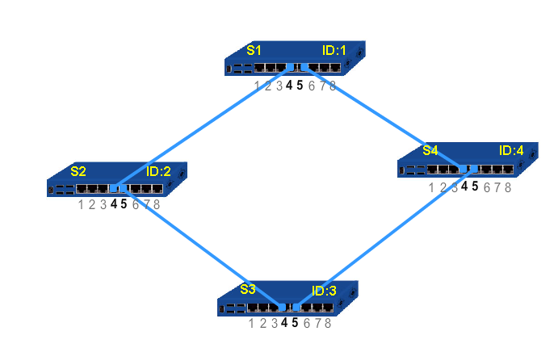

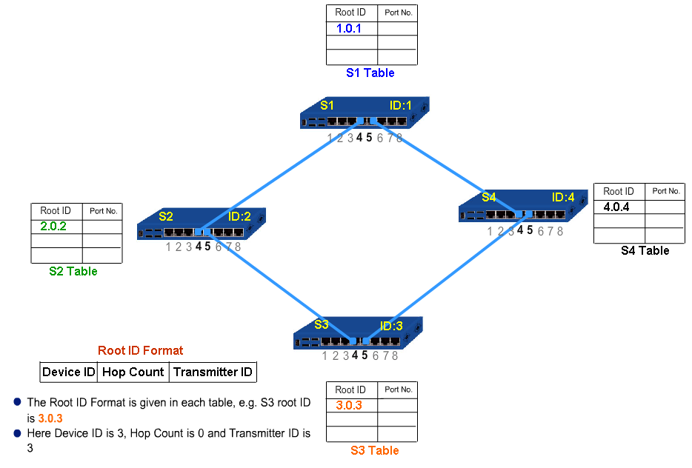

After exchanging packets:

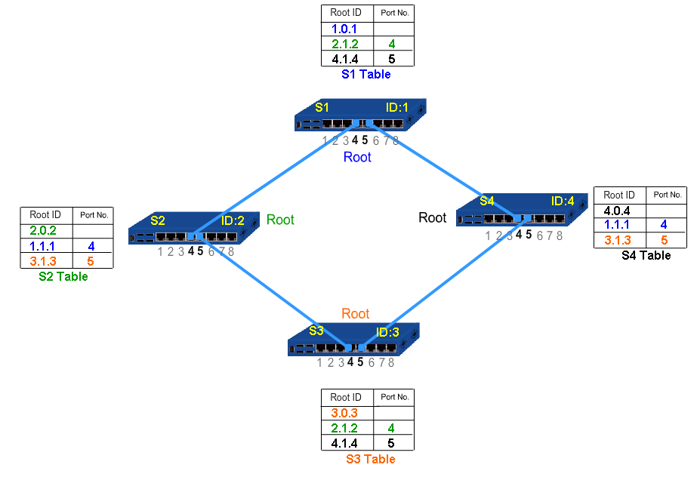
Finding the Least ID

Eventually: The root switch ID is broadcasted to neighbors; NOTE: S1 will not broadcast since there was no change in RootID compare to the previous case (No change in its table value)

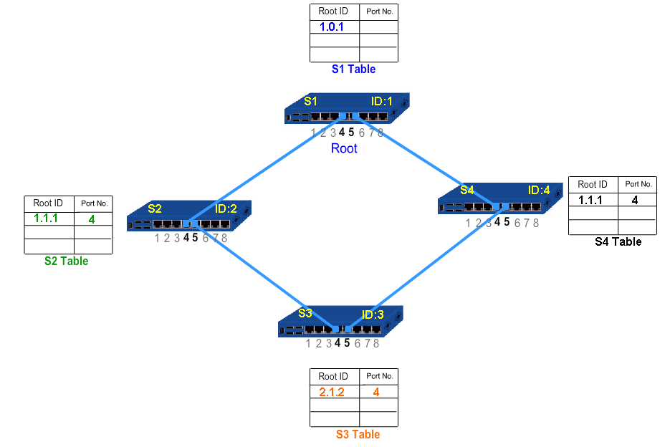
Following a second exchange of RootID each node obtains a new Table values. Note that only S3 changed its table values.
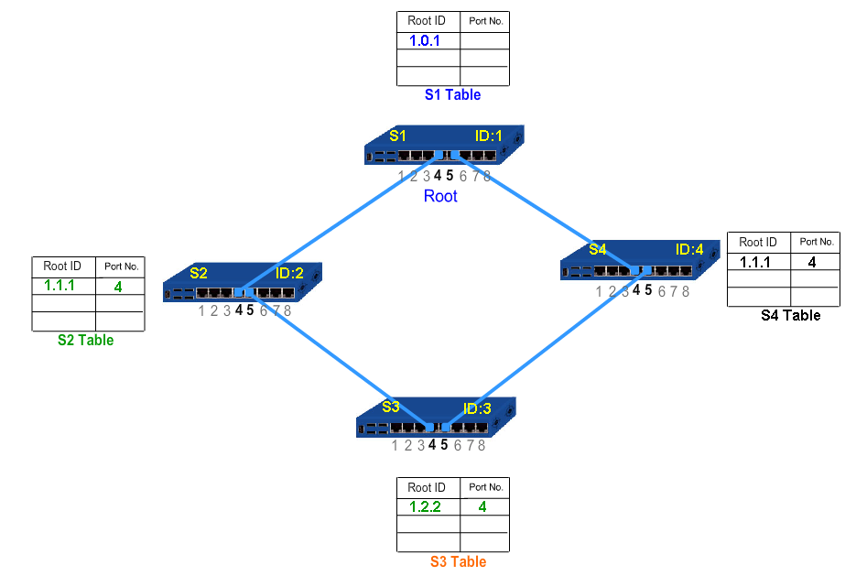
A third RootID exchange is required because the table values of S3 changed. Thus, S3 starts broadcasting its RootID to all its neighbors.
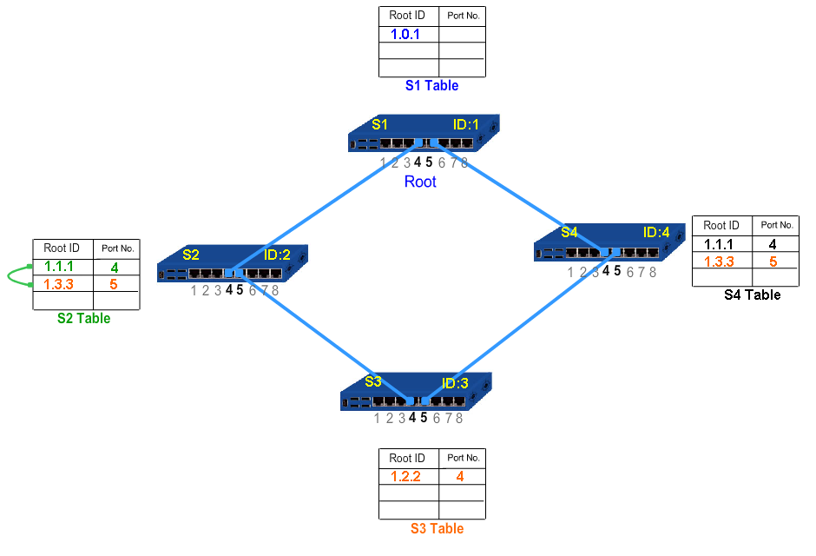
The received values are compared with previous rootIDs in the table and the node picks the smallest RootID with the smallest hop count. Consequently, ports leading to RootIDs are forwarded and other ports are blocked.
