Connect the patch panel as shown below. Make sure all four stations can ping each other. This is very similar to what we did in Basic_lab.

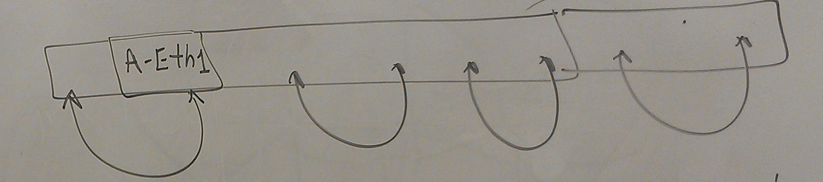

Make sure only Eth1 in enabled on all the computers. Rearrange the LAN cables from the patch panel to the HUB as shown below. Make sure all the stations are reachable (via ping).

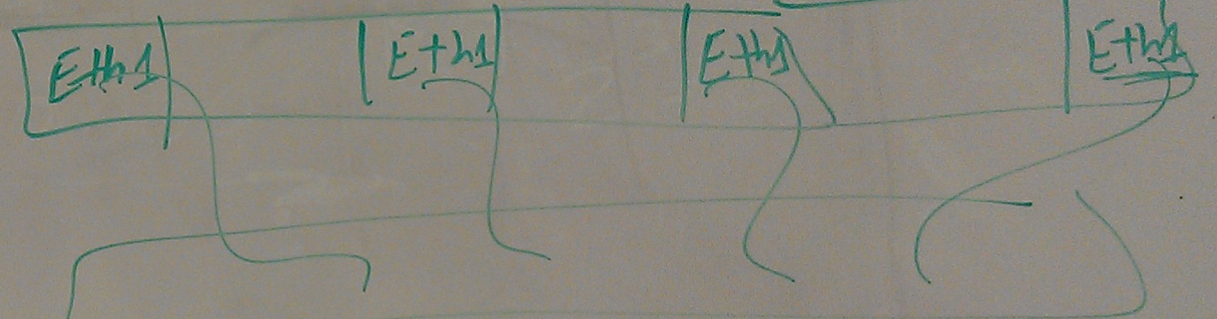

Turn on the tcpdump and observe the packets as different hosts ping each other.

Answer the following questions:

1. What is the purpose of ARP protocol?
2. On your subnet, assume you are terminal A. Make sure wireshark is closed. Answer the following questions:
   1. What happens if B pings C? What will appear in the A’s ARP cache?
   2. What happens if A pings C? What will appear in the A’s ARP cache?
3. Run tcpdump on terminal A. What is the right command if you want to only receive packets with specific source address.
4. Draw ARP packet encapsulation.
5. What is the type ID when Ethernet frame is carrying ARP?
6. Assume the ARP cache of a source is clear. Show the timing diagram when this node pings another host two times.