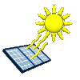

**Simulating Basic Circuits**

**Author**: Farid Farahmand

**Date Created**: August 28, 2012

**Subject**: Introduction to Electricity and Basic Circuits

**Requirements**: Read [Lecture](http://www.sonoma.edu/users/f/farahman/sonoma/courses/es110/es110_more_files/es110_lec1.ppt): Electricity; Ohm's law; Power

**Time Required to Complete**: 2 Hours

**Materials per Group**: Simulator

Reference:

< Your Name >

<Date>

Time it took you to complete this activity: __________

## Part I: Measuring Electrical Properties of a Simple Circuit

In this experiment you measure electrical properties of a simple circuit using an online simulator.

**Pre-Lab Concepts:**

* Understanding DC/AC
* Ohm’s Law
* DMM

**Reference:**

* [Lecture](http://www.sonoma.edu/users/f/farahman/sonoma/courses/es110/es110_more_files/es110_lec1.ppt): Electricity; Ohm's law; Power Slides

**Experiment:**

1. Download (or run) the DC simulator: <http://phet.colorado.edu/en/simulation/circuit-construction-kit-dc> - Note that the simulator operates the best when Windows Explorer is used.
2. Using the simulator, create the circuit shown in Figure 1 (all resistor values, R1-R4, are in Ohm) –

R1; 15 OHM

R1; 15 OHM

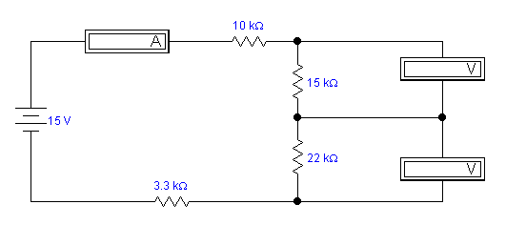

ohm

Oh ohmm

ohm

ohm

Figure 1

R1: 10 Ohm

R2: 15 Ohm

R3: 22 Ohm

R4: 3.3 Ohm

1. Take a snapshot of your circuit and paste it in your report below.
2. Calculate the total resistance of the circuit above: _________________ (Don’t forget the unit)
3. Calculate the total current for the circuit above: _______________________
4. Calculate the total power for the circuit above: _______________________
5. Using the simulator measure all the voltages across resistors R1-R4. You need to do this one-by-one. Enter your results n the table below.
6. Measure the current passing through R1.
7. What are the colors of a 22-ohm resistor? Use the <http://www.abcsemiconductors.com/resistanceang/resistance.phtml> and assume Carbon 4-band type.
8. Create an EXCEL sheet, as shown below, and complete it using the results from the simulator:

|  |  |  |  |
| --- | --- | --- | --- |
| Voltage Source (V) 🡪 | 15 V | 6V | 3V |
| Voltage across R1 (V) |  |  |  |
| Voltage across R2 (V) |  |  |  |
| Voltage across R3 (V) |  |  |  |
| Voltage across R4 (V) |  |  |  |
| Current through R1 (A) |  |  |  |
| Current through R2 (A) |  |  |  |
| Current through R3 (A) |  |  |  |
| Current through R4 (A) |  |  |  |

1. Which resistor has the least amount of current passing through it?
2. Which resistor exhibits the most amount of potential difference?
3. For the circuit above, using the results in the table, plot measured Total–Dissipated-Power against Voltage-Source. On the same plot include your calculated values for each case. Your results should look something like this:

## Part I: Measuring Electrical Characteristics

In this experiment you simulate the amount of power dissipated by a simple light bulb.

1. Create the circuit shown in Figure 2. Assume the resistor value is 10 ohm and the battery voltage is 9 V. The 10-ohm resistor represents wire resistance.

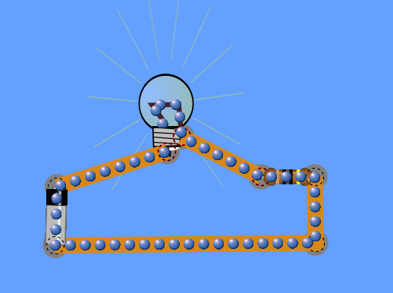

1. What is the REAL direction of current? What is the Conventional direction of current?
2. Calculate the power dissipation by the light bulb. What happens to this power? Where does it go?
3. What happens if the resistance of the WIRE is doubled? Clearly explain your answer.

Briefly explain what you learned in this activity: