Lab Assignment

Review available resources on the web:
http://www.sonoma.edu/users/f/farahman/sonoma/projects/ca/labviewindex.htm

In-class Lab 1: Introduction to LabVIEW
- Read http://cnx.org/content/m19837/latest/ .
- Follow the steps up to Profile Tool Section. In this lab you create a VI to calculate sum and average of several numbers.
- When you complete the code show it to the instructor.
- If you have extra time, you can start working on the homework (see below).

Homework:
The homework assignment must be done individually. If you copy the program from another student, both of you will receive zero for this assignment.

Watch the video (30 min. only): http://www.ni.com/swf/presentation/us/labview/aap/default.htm

Assignment 1:
Create a simple program that can convert a temperature from the Celsius scale to the Fahrenheit scale: http://www.cs.utexas.edu/~scottm/firstbytes/lab1.htm . Take a snap shot of the Front panel and Diagram. Place the figures in the table below.

Snap shot here!
Figure 1. Front Panel VI for Temperature Converter.
Snap shot here!
Figure 2. Block Diagram for Temperature Converter.

Assignment 2:
Change the code below such that the program generates random numbers between 1-100. Make sure your program works properly. Test it for several values. Take a snap shot of the Front panel and Diagram. Place the figures in the table below. You can always use the help menu to find Vis. See the notes below for more information.
- Run the program and then stop the program using STOP bottom on you VI.
- Note that the MEAN value has changed to something between 0-10.
- Also note that you are expected to provide a file name (call it test.xlx)
- Find the generated file (test.xlx) and open it using EXCEL.
- There are the values you recorded using your VI.
- Plot these values using EXCEL. Paste your plot in the table below.
- Explain how you can get a data point every 10 minutes. What do you have to do?
- Using the help menu learn about the MEAN.vi. Open the example and see how it works.

Snap shot here!
Figure 3. Front Panel VI for Random Number Generator.
Snap shot here!
Figure 4. Block Diagram for Random Number Generator.
Snap shot here!
Figure 5. Excel Plot

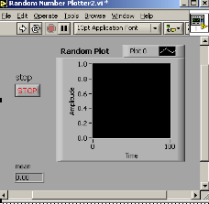
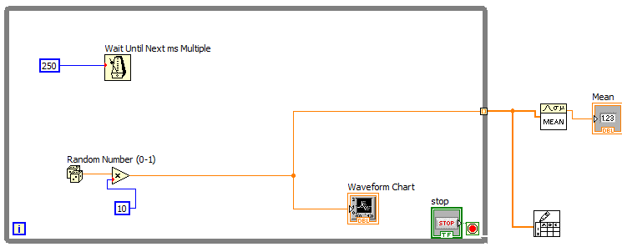
Notes:
Random VI is under programming → Timing
Type Mean.vi in the help/search menu and drop it in your diagram.
The Write_to_Spread_sheet can be found in programming→File I/O

